Health Information Date__________
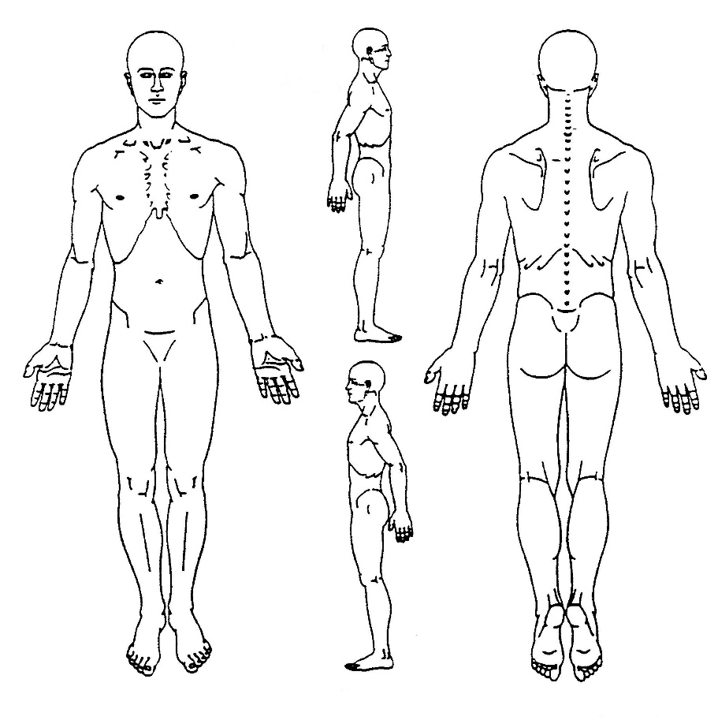What is the BIGGEST reason for your visit today? _____________________________________________
Please use the following symbols to mark where you are experiencing pain/discomfort:
x x x x x - Aching
^^^^^^ - Sharp/Stabbing
oooooo - Pins and Needles
====== - Numbness
~~~~~~ - Burning
When did this problem begin? _____________
What were you doing when it began? (If unsure, write unsure) __________________________________
List procedures, specialists, and other procedures that you have had performed for this problem so far _____________________________________________________________________________________
This problem is getting: □ better □ worse □ staying the same
What makes your problem LESS noticeable? (if nothing, write nothing) _____________________________________________________________________________________
What makes your problem MORE noticeable? _______________________________________________
How would you rate your problem on a 0 to 10 scale, 0 being the least, 10 being the most: ___________
List any medications, and what you take them for ____________________________________________
_____________________________________________________________________________________
Have you had any other changes in your health in the past year □ yes □ no
If yes, describe ________________________________________________________________________

